**22201502**

**Abdullah al mahmud**

**TASK 2 : NS-3**

Screenshots of data packets

Packet size 128

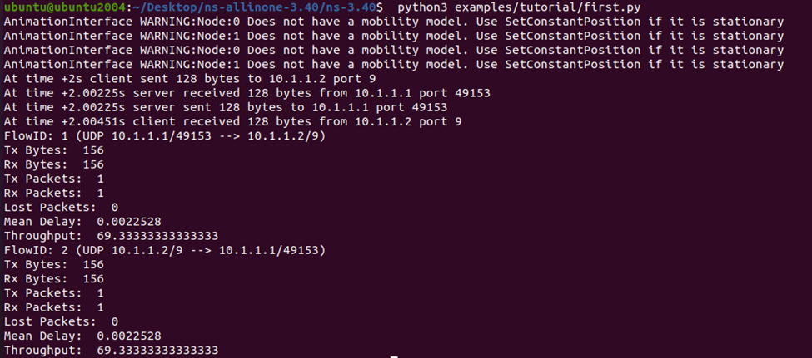

Throughput 69.3333

Packet size 256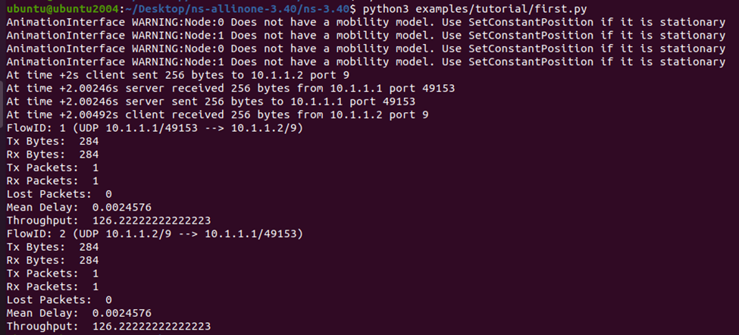

Throughput 126.2222

Packet size 512

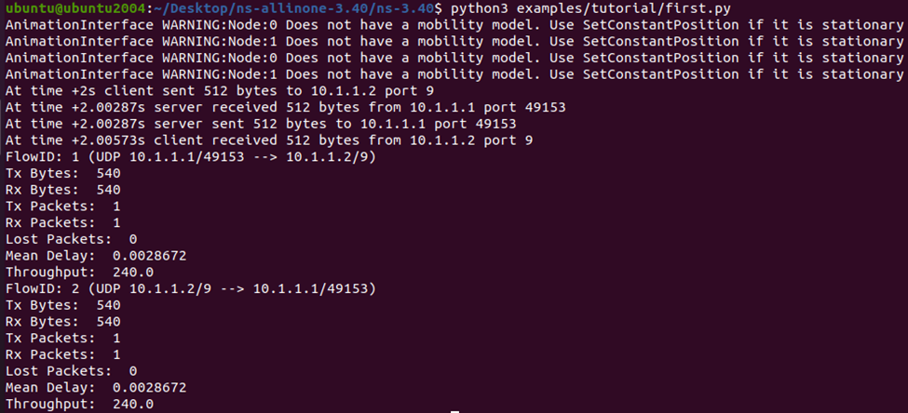

Throughput 240.0

Packet size 1024

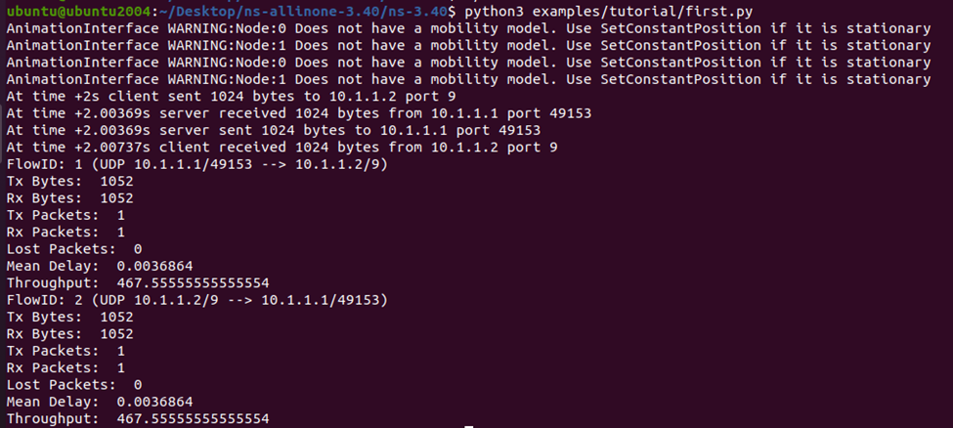

Throughput 467.555

Packet size 2048

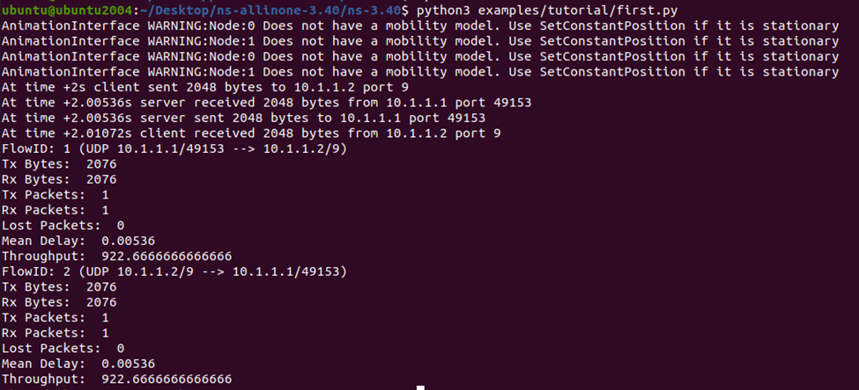

Throughput 922.666

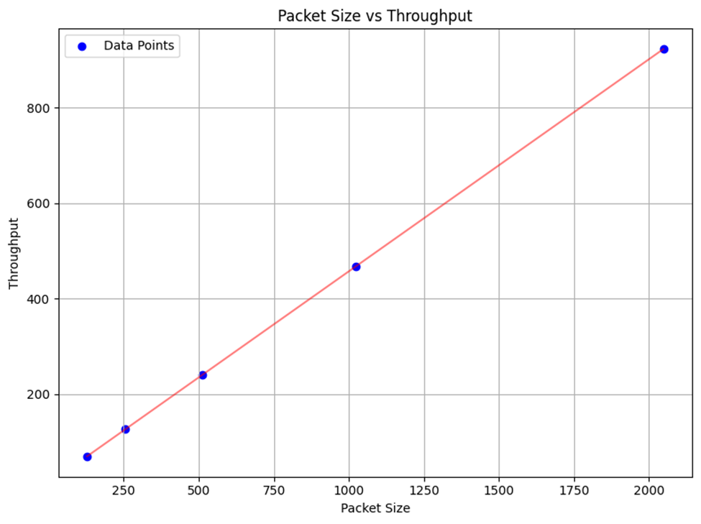

Graph :

Throughput is positively correlated to packet size because as packet size is increasing and throughput is also increasing. Thus a larger data packet can use the data link larger amount of bandwidth for data transmission in comparison to a smaller packet size.